6.1 Process Overview

Process | Owner
Documented process and procedure for Freedom and rights of a Data Subject in compliance with the New GDPR Legislation | Sirona Medical : Simon (MD)

Scope Statement

Gathering and documenting of personal and sensitive data flow process and procedures including assets used to process such information in line with GDPR regulations

Purpose of Process
Gain an insight into how data is obtained, transferred, stored and processed in Line with the New GDPR regulation
.

Summary

According to the process map and details of its components in this process
- The lawful basis for processing data includes legal obligation, employment law, consent, and legitimate business interest
- Does not include cross border transfer
- Includes transfer of data outside the EEA.
- It Includes both personal and sensitive data

6.2 Data Map

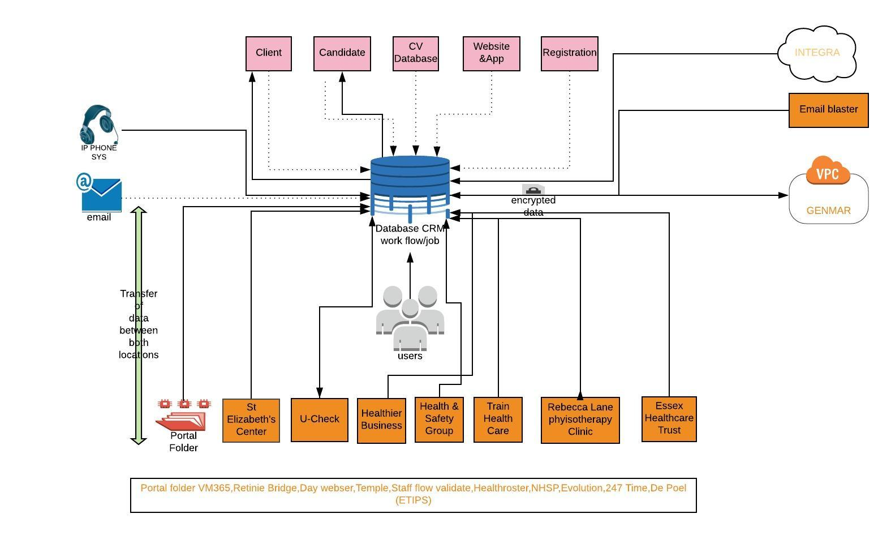

6.3 Personal data Inventory
Personal data relates to any information relating to the identified or identifiable natural person (Data Subject).

Summary

Include some special category data.
- The lawful basis for processing 5 data items is Employment law
- The lawful basis for processing 3 data items is Contractual obligation
- The lawful basis for processing 4 data items is legitimate business Interest
- The lawful basis for processing 3 data items is Consent
Data Item | Data subject |  | Lawful basis
Registration data/CV | Candidate |  | Legitimate business Interest
Age | Candidate | Employment Law
Name | Candidate | Legitimate business Interest
Gender | Candidate | Contractual Obligation
DBS Number | Candidate | Employment Law
Passport number | Candidate/Employee | Employment law
N.I Number | Candidate/Employee | Employment Law
Phone number | Candidate/Client/  Contractor | Legitimate business Interest
Email address | Candidate/Client/  Contractor | Legitimate business interest
Bank details | Employee/contractors | Contractual Obligation
Nurse Registration Number | Candidate | Employment law
Blood type Data | Candidate | Legal Obligation
Login/User details | Candidate/Employees | Contractual Obligation
Cookies | Candidate | Consent
IP address | Candidate | Consent
Photograph | Candidate | Consent
Job Title | Candidate |  | Legitimate business Interest

6.4 Asset Register

Name/Asset | Location | Operator | Records | Comments
ECLIPSE | UK | Controller | All Data records | Internal CRM
GEMMAR | UK/Outside EEA | Joint  ! | All Data Record | Third party agreement review
INTEGRA | UK | Joint | HR Records | Third party agreement review
WEBSITE AND MOBILE APP | UK | Controller | Registration data/ cookies/IP | Data and Acceptance User Policy
EMAIL SERVER | UK | Controller | All Data Records | SSL, Encryption by default
IP PHONE SYSTEM | UK | Controller | Registration data | Grand stream connected to CRM

